How to use the MIDIRS Database

Step 1: Logging in
The MIDIRS Database is available from the MIDIRS main website www.midirs.org Click on the link to the “On-Line Service Login” in the top right hand corner of the MIDIRS homepage. You will be asked to enter your user name and password at the screen shown below. Click on the Login button.

Step 2: The Database homepage
At the Database homepage, you are offered three methods of searching the Database, by “Categorised Standard Search”, by an “Advanced Search” or by entering a “Standard Search” code. Click on the links to select your preferred method of searching.

Step 3: The Categorised Standard Search
When records on particularly common topics in maternity care are entered onto the Database by the MIDIRS team, we assign them to one or more of 400+ “Standard Searches” by use of a code number. This means that you can search for records on a particular topic in a single search. There is a maximum of 250 records in each Standard Search, and we also offer archive searches with older records on selected topics.

The Categorised Standard Search option guides you to select the correct Standard Search for your research needs. At the first menu, you may select a “top-level” search category (Breastfeeding; Labour and Delivery; Maternity Services; Midwifery; Neonatal Care; Postnatal Care; or Pregnancy), after which you are offered a second menu to choose options under this category, and then a third menu to select a narrowly defined Standard Search.

In the above example, code L17 refers to the Standard Search on shoulder dystocia. If you already know the code number which relates to a particular standard search, you can simply enter this after selecting the third search method from the Database homepage “Search Standard Searches”. A full list of Standard Search codes is printed on the back pages of the MIDIRS publication “A Guide to Services” or can be obtained by telephoning MIDIRS’ Information Services team on +44 (0) 117 907 7593 or email info@midirs.org

Step 4: The Advanced Search
If your search does not fall into one of the Standard Search categories, or if you prefer to conduct a wider or more flexible search, you can select to perform an Advanced Search from the option at the Database homepage.

Enter your search terms in the search box provided. You can combine terms by clicking on the options And, Or, or Not (the Boolean operators). You can also select to search on an author’s name, a particular publication, or on a keyword term by clicking the option boxes provided. Then click on Search.

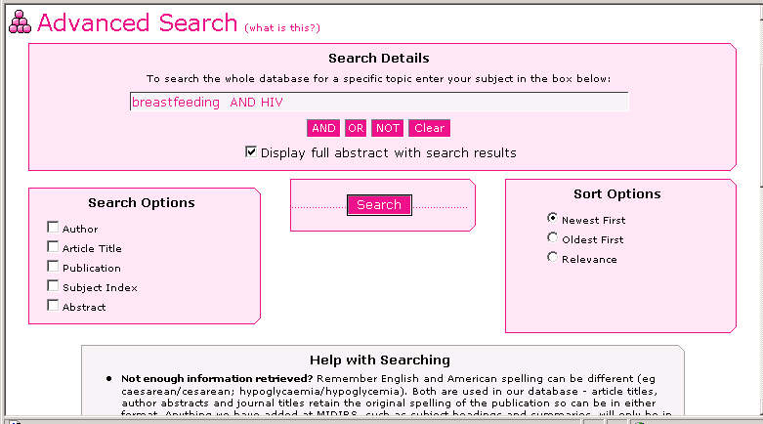

* Please note* If you wish your records to be returned with the full abstract of the item included, you must tick the box next to “Display full abstract with search results” which appears directly below the search box.

Step 5: Retrieving your results

The results of your Categorised Standard Search or your Advanced Search should appear within seconds. Each record should feature the author, title, name of publication, and the date, and most items will feature keywords, and a description of the item type (original research, review, commentary etc). The keywords are hyperlinked, and it is possible to click on them to retrieve other records on the same topic (although it is advisable to click on an uncommon keyword rather than a very general term such as “breastfeeding” as this will generate a lot of hits!).

If you have selected for the abstract to appear with your results (see above), in the majority of cases you will be presented with either an author abstract or an abstract written by a member of the MIDIRS team. All abstracts include either (Author) or the initials of the MIDIRS abstract writer to indicate the abstract type.

The majority of records also feature the number of references (citations) listed in the item. Finally, if the item is available from a source other than MIDIRS, including an online source, the details of where it may be obtained are given.

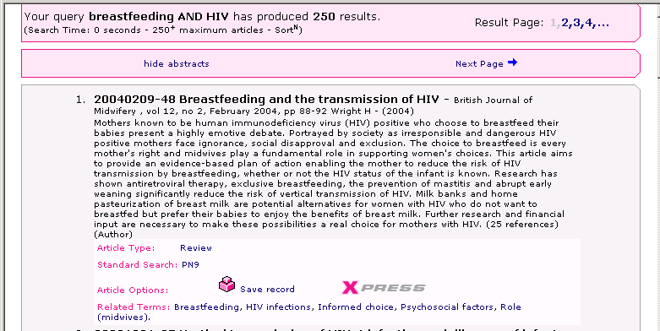

Step 6: Ordering photocopies of articles

Where an item is available for photocopying by the MIDIRS team, an “Xpress” icon appears in the Database record. By clicking on this icon, you are guided step by step through the ordering process. Orders are payable in advance using credit card payment only, and for our standard 5-day service there is a minimum order requirement of two items. The Xpress service uses a secure credit card facility to protect your details.

*Please note* photocopies can only be provided in compliance with current UK copyright law. You will be presented with a copyright declaration form which prints automatically when you click to agree its terms. Please sign the printed copy of the form and hand it to your librarian to confirm your compliance with the regulations. Also, under copyright law, we cannot supply more than one article from a single issue of a journal – should you request two items from a journal by mistake, we will supply you with the first article ordered and notify you of our inability to fulfil the whole request.

Step 7: Logging out

Click on the “Logout” button at the top of the screen.

IT IS ESSENTIAL that you log out of the Database correctly if you have earlier entered your credit card details on to the Database to order photocopies.

Step 8 – Getting additional help

There is help available from the Database, including tips on getting the best results from an Advanced Search. Should you require any further help, MIDIRS has a team of professionally qualified information officers who are more than happy to help you perform your search. Please telephone +44 (0) 117 907 7593 or email info@midirs.org

